TASK 3: Polynomial Regression model

A car manufacturer wants to predict the fuel efficiency (miles per gallon, MPG) of its vehicles based on engine size, weight, and horsepower. You are tasked with building a Polynomial Regression model to capture non linear relationships between features and MPG.

CODE:

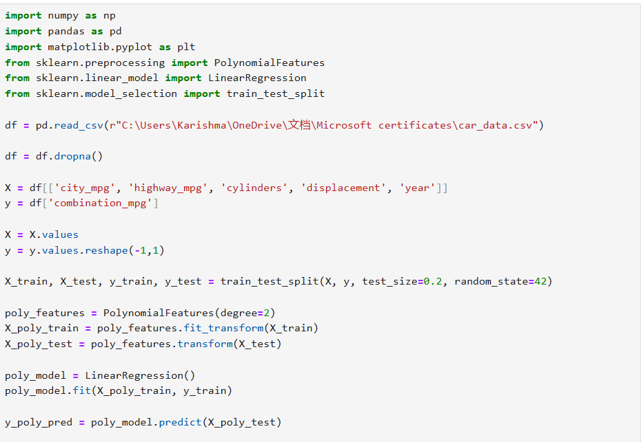
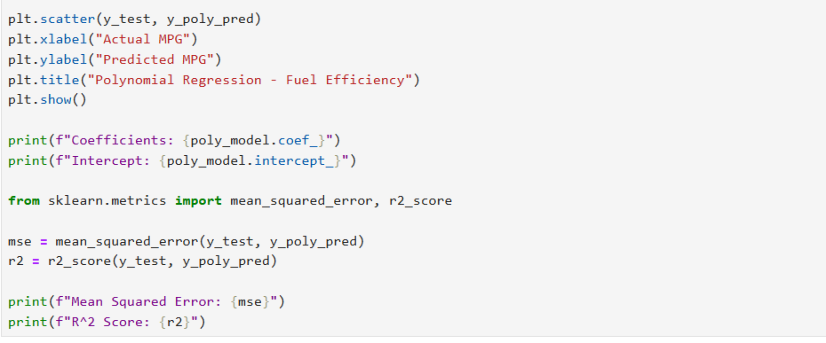

OUTPUT:
